**BITS PILANI, DUBAI CAMPUS**

**DUBAI INTERNATIONAL ACADEMIC CITY, DUBAI**

**FIRST SEMESTER 2023 – 2024**

**COURSE:** CSF301 (Principles of Programming Languages)

COMPONENT: Tutorial Sheet 5b DATE: 25 October 2023

**I. DRAW the layout of the Activation Record (Stack frame) for the following segment of C code:**

**#include<stdio.h>**

**void myfun(int *a, int *b);**

**int main()**

**{**

**int m = 10, n = 20;**

**printf("\n m = %d \n n = %d",m, n);**

**myfun(&m, &n);**

**}**

**void myfun(int *a, int *b)**

**{**

**int tmp1, tmp2;**

**tmp1 = *a + *b;**

**tmp2 = *b - *a;**

**printf("\n tmp1 = %d \n tmp2 = %d \n", tmp1, tmp2);**

**}**

**II. Practice Problem:**

**DRAW the layout of the Activation Record (Stack frame) for the following segment of C code:**

**#include <stdio.h>**

**float square ( float x ) // function definition**

**{**

**float p ;**

**p = x * x ;**

**return p;**

**}**

**void main( )**

**{**

**float m = 25, n ;**

**// function call**

**n = square (m) ;**

**printf ("%f %f\n", m,n);**

**}**

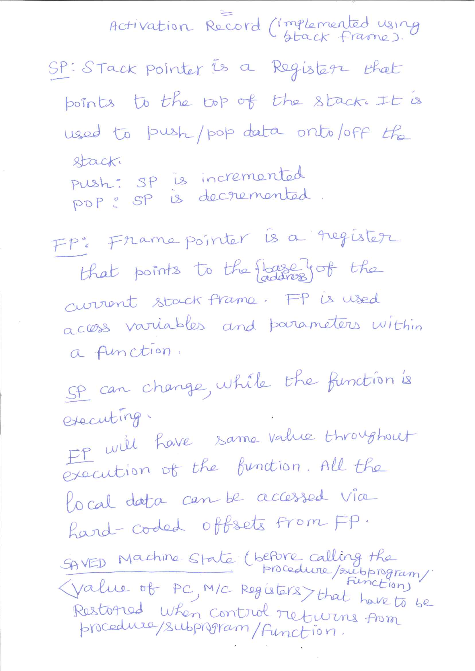

Suggested Answer: I

